**Analysis on Economic Growth & Population Dynamics**

**Project Overview** The **Economic Growth & Population Dynamics** project examines economic and population trends across countries using datasets on **GDP, population, life expectancy, literacy rates, and other socio-economic indicators**. By analyzing these factors over several decades (1960–2016), the project uncovers patterns, correlations, and insights that support data-driven decision-making for policymakers, economists, and researchers.

**Dataset Description**

* The analysis integrates data from multiple sources, including:
* **Global Economic Indicators Dataset**
* **GDP Trends (1960–2016)**
* **Country-wise Population Data and Metadata**

**Key Metrics Analyzed:**

* **GDP per capita**
* **Population growth rates**
* **Life expectancy**
* **Urbanization and literacy rates**

**Data Cleaning & Transformation**

* To ensure accuracy and consistency, the following steps were applied:  
   **Duplicate Removal** – Eliminating repeated records  
   **Handling Missing Values** – Using imputation or deletion techniques  
   **Standardization** – Ensuring consistency in formats (date, numeric values)  
   **Data Integration** – Merging multiple datasets  
   **Validation** – Cross-checking processed data

**Descriptive Statistical Analysis**

* Basic statistics were applied to extract insights, including:  
    
   **Mean, Median, Mode** for GDP, life expectancy, and population growth  
   **Trend & Outlier Identification** over time  
   **Comparative Analysis** across countries and regions

**DAX Calculations for Insights**

* Power BI (or equivalent tools) was used for advanced metrics:  
   **GDP Growth Rate** (annual and cumulative)  
   **Average & Median Population**  
   **Total GDP by Region**  
   **Population Growth Rate (%)**  
   **Custom Country Rankings** based on economic and demographic performance

**Dashboard Overview:** 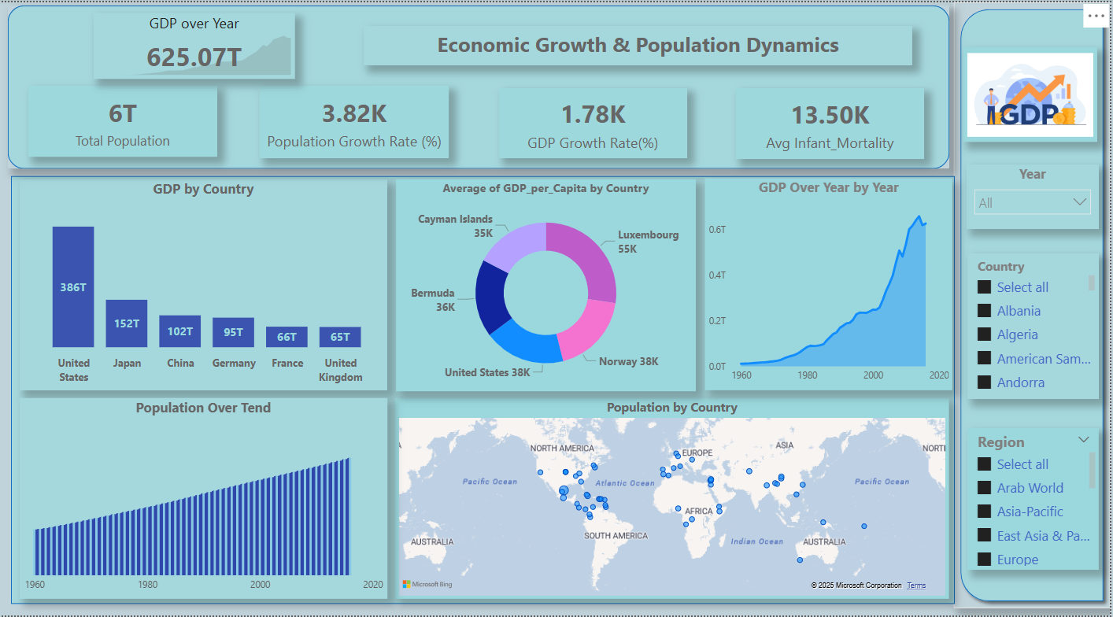

**Insights:**

**1) Population Growth (1960 - 2020)**

* Steady and linear growth from 61B (1960) to 158B (2020).
* No major dips, indicating consistent birth rates
* Driven by advancements in healthcare, agriculture, and living standards.

**GDP per Capita Insights**

* **Causes:** War (Yemen), weak infrastructure, poverty, and low industrialization.
* **Impact:** Low wages, high unemployment, poor healthcare, and lower living standards.

**Migration:**

* **Highest Migration Rate:** Countries like **French Guiana, Hong Kong, and Belgium** (above 44K) attract more migrants, likely due to better job opportunities, economic stability, and quality of life.
* **Lowest Migration Rate:** Countries like **Micronesia (-21.0) and American Samoa (-20.7)** face high emigration, possibly due to poor economic conditions, lack of opportunities, or environmental challenges.

**Sector wise insight:**

* Service sector dominates with 118.08, contributing the most to the economy.
* Industry sector (59.04) is half the size of services, indicating a developing or service-driven economy.
* Agriculture (31.36) is the smallest, contributing 26.6%, suggesting a shift away from traditional farming towards industrial and service-based growth.

**Recommendation based on analysis:**

**1) GDP Growth**

* Invest in education, technology, and infrastructure
* Diversify economic growth sectors for stability

Strong technology, Agriculture, Tourism, and manufacturing sectors

* Enhance trade, FDI, and entrepreneurship
* Implement sustainable and inclusive policies

**2) To increase GDP per capita**

* **(Zambia, Yemen):** Diversify industries, invest in tech & innovation.
* **(Uzbekistan , Zimbabwe):** Economic reforms, improve infrastructure & trade.
* Attract foreign investment, boost education & skills, diversify economy.

**3) Reduce Migration rate**

* **For Low Migration Countries:** Improve job opportunities, infrastructure, and living conditions to retain citizens.
* **For High Migration Countries:** Develop policies to manage population growth, housing, and social services effectively.

**4) Sector**

* **Boost Industry & Agriculture** – Invest in industrialization & modern farming.
* **Enhance Service Sector** – Improve skills, tech, & infrastructure.
* **Diversify Economy** – Promote manufacturing, exports, & innovation.